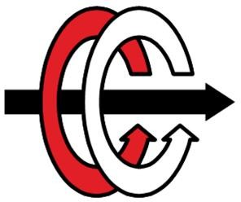cihaz, rüzgar değirmeni, rüzgar türbini, rüzgar çiftliği içeren bir resim

Açıklama otomatik olarak oluşturuldu

Middle East Technical University

Department of Electrical and Electronics Engineering

# EE463: Static Power Conversion I

# Term Project Simulation Report

**Group Name:** Battery Voltas

**Student 1:** Elif Topaloğlu - 2443984

**Student 2:** Erkin Atay Toka - 2443968

**Student 3:** Doruk Yazıcı - 2517225

**Submission Date:** 03.12.2023

# Introduction

The aim of this project is to design a battery charger whose input power is supplied by a small wind turbine generator. The design should convert the varying AC voltage to DC voltage and current within the battery voltage and charge limitations. Battery and wind turbine specifications are available at the [project GitHub repository](https://github.com/odtu/ee463/tree/master/Hardware%20Project#specs).

In this report, the candidate AC to DC topologies for battery charging are discussed, and the analytical calculations and simulation results regarding the selected topology are displayed. Then, according to these results, the candidate components are chosen.

This project is still ongoing and evolving.

# Topology Selection

In order to control the output current and voltage, a controlled rectifier topology or a diode rectifier + buck converter topology must be selected. All the topologies that are considered are listed below.

* *Single-phase thyristor rectifier:* This topology has the minimum number of components compared to other topologies. It includes mainly one gate driver, four thyristors, and some passive elements. This makes this topology possibly the cheapest one. However, the average output voltage is insufficient to feed the battery with 12 V when the input voltage range is 15Vll to 25Vll. Hence, this topology is not an applicable choice.
* *Single phase diode rectifier with* *non-inverting buck-boost converter:* This topology consists of one gate driver, passive elements, six diodes, and 2 MOSFETs. A non-inverting buck-boost converter is needed since the average output voltage of the diode rectifier is between 7.8 V and 13 V when the input voltage range is 15Vll to 25Vll without non-idealities. These values are calculated using the formula given below.

$$V_{d}=\frac{2\sqrt{2}V_{ll}}{\sqrt{3}π}$$

However, when the output voltage of the rectifier is between 12V and 13V, the duty cycle of the buck converter is around 0.9, which is not desired since as DC gets closer to the edges, its output becomes unstable and non-reliable. Moreover, control of this topology is more complicated due to the non-inverting buck-boost converter. Furthermore, it consists of more components than a phase diode rectifier with a buck converter, whose control is relatively more straightforward.

* *Three-phase thyristor rectifier:* This topology consists of one gate driver, six thyristors, and some passive elements. The average output of a three-phase thyristor rectifier is given below.

$$V_{d}=\frac{3\sqrt{2}V_{ll}}{π} cos⁡(α)$$

The firing angle is between 53.67 and 69.18 degrees to feed a 12 V battery when the input voltage range is 15Vll to 25Vll. Although this topology is comparable with the three-phase diode rectifier with a buck converter, this topology is not chosen since it is more prone to errors at the controller part.

* *Three-phase diode rectifier with buck converter:* This topology consists of one gate driver, seven diodes, 1 MOSFET, and some passive elements. The average output of a three-phase diode rectifier with a buck converter is given below.

$$V_{d}=\frac{3\sqrt{2}V_{ll}}{π} D$$

The duty cycle is between 0.355 to 0.6 to feed a 12 V battery when the input voltage range is 15Vll to 25Vll. These values are obtainable for buck converters. Moreover, compared to single-phase topologies, the input current THD is lowered due to the cancellation of 3rd harmonics, and the output voltage rippler magnitude and frequency decrease. This results in smaller passive components for filtering purposes. Also, compared to a phase thyristor rectifier, control of this topology is easier.

* *Three-phase diode rectifier with synchronous buck converter:* This topology is mainly the same as the three-phase diode rectifier with buck converter, but the free-wheeling diode at the buck converter is changed with a MOSFET with an inverted gate signal. At a traditional buck converter, the forward voltage of the free-wheeling diode increases the conduction losses, especially at high currents. Changing this diode to a low-resistance MOSFET at the synchronous buck will improve the converter's efficiency. Also, since this application is a low-voltage one, the output voltage can easily be affected by the diode on resistance. Thus, using a synchronous buck converter will be more logical. However, the complexity of the controller is increased due to the added inverted gate signal. Nevertheless, it is worth trying this topology due to the increased efficiency and low voltage drop on MOSFET.

It is determined that both a three-phase diode rectifier with a synchronous buck converter and a three-phase diode rectifier with a buck converter will be tried for charging the battery. Next, we will give the analytical and simulation results for the selected topologies.

# Validation of Design

# General design

metin, ekran görüntüsü, ekran, görüntüleme, yazılım içeren bir resim

Açıklama otomatik olarak oluşturuldumetin, ekran görüntüsü, ekran, görüntüleme, yazılım içeren bir resim

Açıklama otomatik olarak oluşturulduFor the project, we have two selected topologies, namely, a three-phase diode rectifier with a synchronous buck converter and a three-phase diode rectifier with a buck converter. The general and ideal circuit diagram for the two topologies is presented below.

Figure 1. A three-phase rectifier and synchronous buck converter design with low-side driven MOSFET

Figure 2. A three-phase rectifier and buck converter design with low-side driven MOSFET

In this topology, the MOSFET is located on the low side of the circuit rather than the conventional buck converter topology, where the MOSFET is located before the inductor. The reason is that if the source of the MOSFET is connected to a high-voltage side, to use the MOSFET as a switch, a higher voltage should be supplied to the gate of the MOSFET. This complicates the gate driver circuit; therefore, connecting the MOSFET below makes the source side voltage smaller so that giving a smaller voltage to the gate will open the switch that eases the gate driver circuit design without changing the actual operation principle of the buck converter.

# Analytical calculations

In this project, as the main aim is to charge the battery with the power supplied by the wind turbine, there will be two sides, namely the input side, which has variable AC voltage representing the wind turbine, and the output side, which is the battery with constant current and voltage (DC). The specifications of this system are presented below.

* Input voltage: ${15 V}_{line_to_line}$ to $25 V_{line_to_line}$
* Battery capacity: 100 Ah
* Battery nominal voltage: 12 V
* Output current: 10 A
* Output current ripple: 20% of average current

Considering the specifications of the project, analytical calculations are done for the ideal selected designs, which consist of a three-phase full-bridge diode rectifier and buck converter. Analytical calculations give a general understanding of the system and the values of the circuit elements, duty cycle, etc. After the ideal component values are calculated, further arrangements are made in the simulation to obtain a better working system. In order not to set the simulation values far from being reasonable and by just arranging the values by trial and error, having an insight into the component values is valuable, which necessitates the analytical calculation part. Analytical calculations done before the simulation are presented below.

First, the average output of the three-phase full-bridge diode rectifier is calculated as it is the input of the buck converter and determines the required duty cycle values for the project. Using the formula below, maximum and minimum input voltage values for the buck converter are calculated.

$$V_{out, average}=\frac{3\sqrt{2}}{π}*V_{line-to-line}$$

$$V_{in,min}=\frac{3\sqrt{2}}{π}*15≅20.3 V$$

$$V_{in,max}=\frac{3\sqrt{2}}{π}*25≅33.8 V$$ If the nominal output battery voltage is known, using the input voltages of the buck converter and the output nominal voltage, the maximum and minimum duty cycles required for the project can be calculated.

$$D_{max}=\frac{V_{out}}{V_{in,min}}=\frac{12}{20.3}≅0.59 \\ D_{min}=\frac{V_{out}}{V_{in,max}}=\frac{12}{33.8}≅0.36$$

One of the most essential elements of the buck converter is the inductor. The inductance value should be calculated to have the buck converter functioning appropriately. There are two operating modes of a buck converter: continuous conduction and discontinuous conduction. In the continuous conduction mode, the inductor current is always positive, and for the discontinuous conduction mode, the current is positive for some time and zero otherwise. The point where the minimum inductor current equals zero is defined as the critical conduction mode. The inductance value calculated for this mode is called the required inductance, and if one wants to operate in the continuous conduction mode, the selected inductance should be larger than the critical inductance value. The calculation of the critical inductance is given below.

$$L_{critical}=\frac{(1-D_{max⁡})*V_{max}}{2*f_{s}*I_{out}*{(1-I}_{ripple})}$$

$$L_{critical}=\frac{(1-0.59)*12}{2*{10}^{3}*10*0.8}≅30.6 µH$$

For this calculation, the switching frequency is used and selected as 10 kHz. The reason for this selection can be understood by examining the effects of switching frequency. If the switching frequency increases, the output current ripple decreases, which is desired for this system. Due to this reason, a low switching frequency cannot be selected as it is not possible to meet the maximum 20% current ripple criterion. With low frequency, this criterion can be met by increasing the inductance value; however, increasing it makes the inductor bigger and more expensive. Therefore, a neat design for low switching frequency selection cannot be achieved. Moreover, increasing the frequency is not desired as it increases the loss due to switching. Therefore, a 10 kHz switching frequency is selected as it is reasonable and adequate regarding the requirements and efficiency concerns.

For the aim of protection due to the abrupt changes of the current and voltage due to switches, snubber circuits need to be presented for the design. The values for the RC snubber should be selected properly so that the switching elements, like diodes and MOSFETs, are protected from impulsive current and voltage changes. RC snubber is used for this purpose, and according to the results obtained from the simulation done in MATLAB Simulink software, resistance, and inductance values are calculated using the formulas presented below.[3] In the formulas, $V_{off}$ represents the voltage across the switch when it is off and $I_{on}$ is the current when the switch is on.

$$R_{snubber}≤\frac{V_{off}}{I_{on}}$$

$$C_{snubber}=\frac{1}{V_{o}^{2}*f_{s}}$$

Finally, the capacitor for input and output of the buck converter should be determined. Formulas to calculate these capacitor values are presented below.

$$C_{out}=\frac{\left(1-D_{min}\right)*D_{min}*I_{out,max}}{f_{s}*∆V_{in}}$$

$$C_{out}=\frac{\left(1-0.36\right)*0.36*10*1.2}{{10}^{3}*(33.8-20.3)}≅20.4 µF$$

$$C_{in}=\frac{1-D_{min}}{8*L_{critical}*f_{s}^{2}}$$

$$C_{in}=\frac{1-0.36}{8*30.6*{10}^{-6}*{{10}^{3}}^{2}}≅26.4 µF$$

These calculations are done under the assumption of 100% frequency, which cannot be achieved in real-world design using lossy elements. However, analytical calculations are still necessary to have valuable insight into the element values so that further selection can be improved using the simulation tools easily without blindly following the trial and error method. All the calculations in this part are done using documents that are presented in the reference part of the report. [1] [2] In the following section, simulation results for the design will be presented.

# Simulation results and validation

Simulation is done to validate the three-phase full-bridge diode rectifier with a classical buck converter model. The overall simulation model is presented below without the measurement units for simplicity.

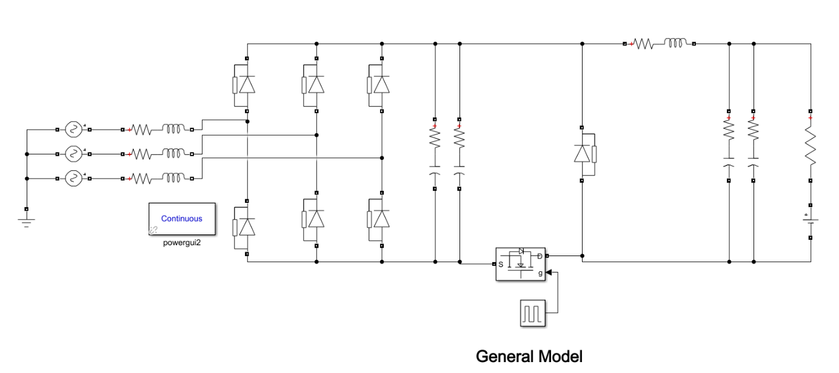

Figure 3. The overall circuit design for a three-phase full-bridge diode rectifier with a classical buck converter

In the simulation in Simulink, a resistor and a DC voltage source series with the resistor are used to simulate the battery at the output.[4] The series resistance value is selected by researching a battery having the same capacity and voltage value.[5]

To obtain more accurate and similar results, components are presented with their non-idealities, which are the series resistances. Also, the commutation effect due to the source inductance is included in the simulations. Moreover, snubber values are calculated using the formulas presented before and included in the simulation both for the diodes and the MOSFETs. Also, in the simulation, input and output capacitors have more than one parallel branch. The reason for multiple parallel capacitors is to decrease the effect of the series resistance of the capacitor (ESR). ESR worsens the output ripple; therefore, by connecting multiple capacitors in parallel, ESR is aimed to be reduced.

The simulation results for this topology are presented below to validate that the design is properly working and meets the voltage requirements and current ripple constraints by approximately having a 10% ripple.

Simulation results for the output voltage and output current of both the rectifier and the buck converter are given below.

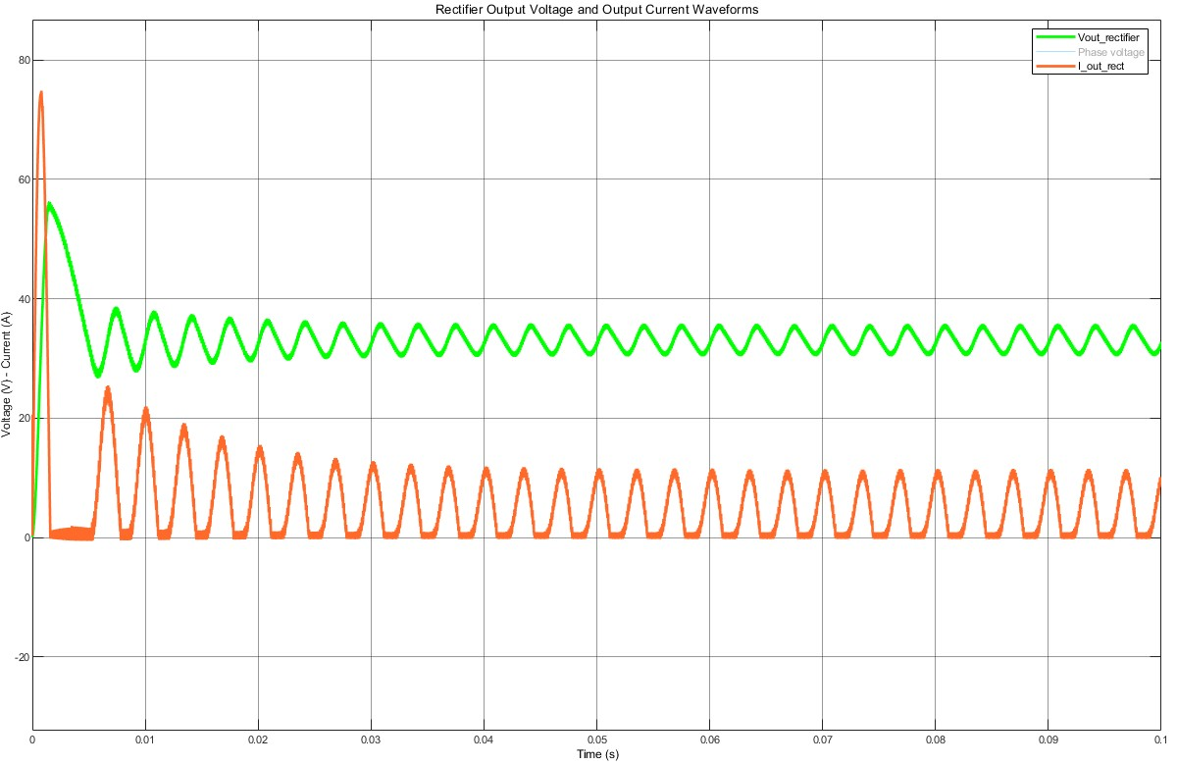

Figure 4. Rectifier output voltage and current waveforms

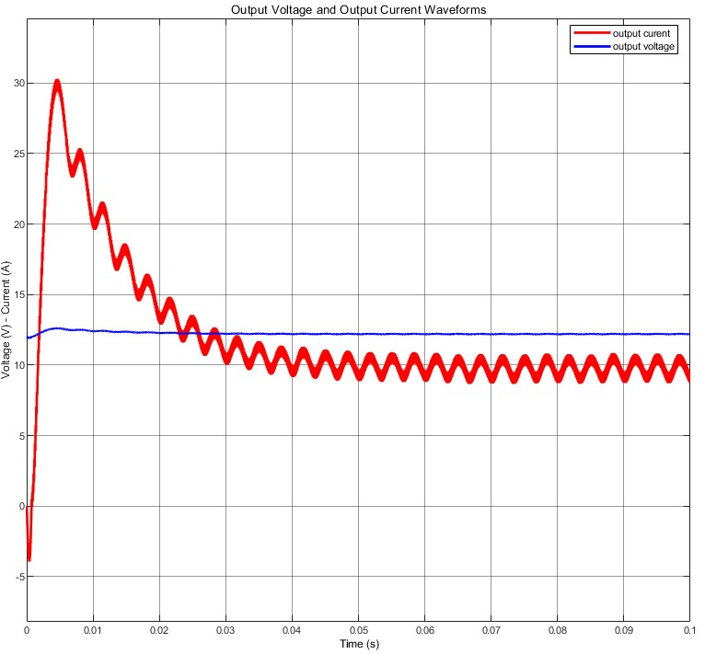

Figure 5. Output voltage and current waveforms of the buck converter

The second simulation is done to validate the three-phase full-bridge diode rectifier with a synchronous buck converter model. The overall simulation model is presented below.

metin, diyagram, plan, teknik çizim içeren bir resim

Açıklama otomatik olarak oluşturuldu

Figure 6. Overall simulation for three-phase full-bridge diode rectifier and synchronous buck converter

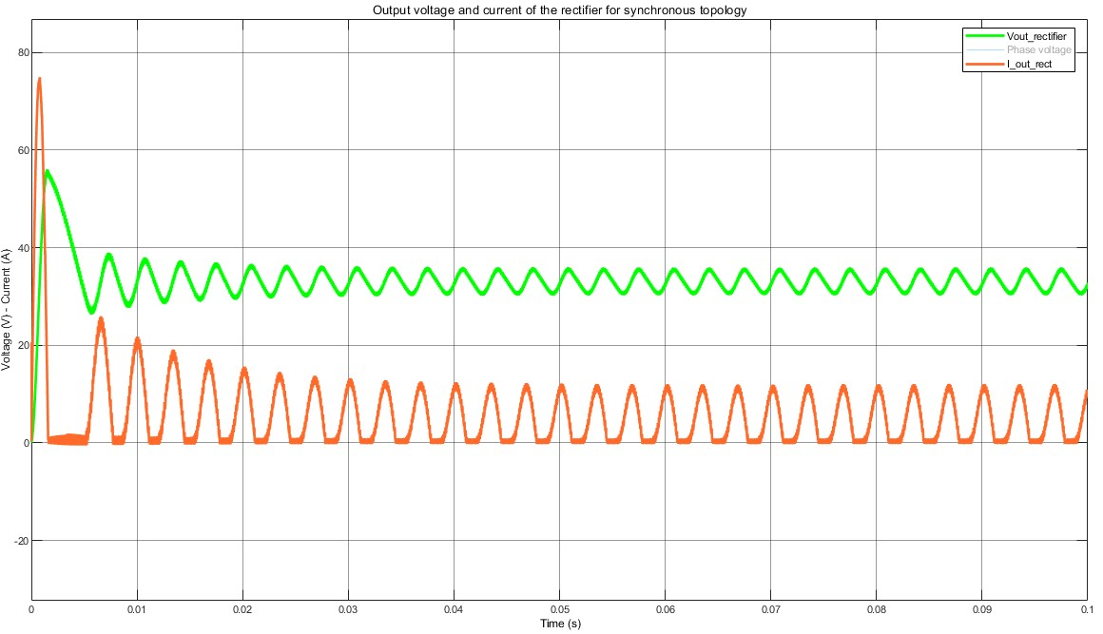For the circuit design using the synchronous buck converter, not much change occurred. Instead of the diode in the buck converter, a MOSFET is used to decrease the losses stemming from the diode. Another important difference is that the MOSFET used instead of the diode has a duty cycle with a 180-degree phase shift for the system to function properly. Therefore, a negative unity gain is implemented in the simulation to achieve this phase shift. The simulation results are presented below. As can be seen from the plots, the exact same outputs can be obtained using this topology; however, the duty cycle required is slightly less for this topology.

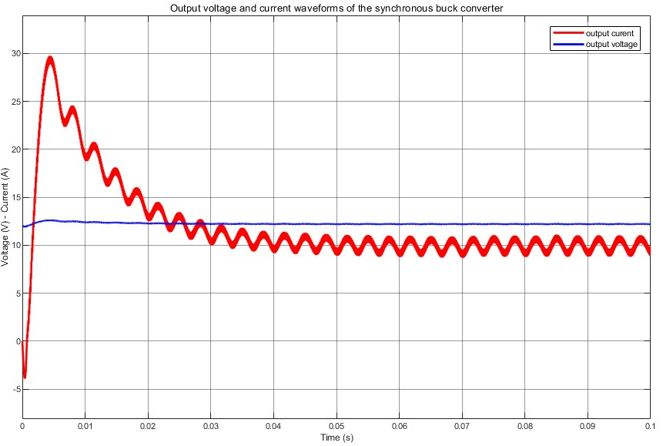Figure 8. Rectifier voltage and current output waveforms for topology, including synchronous buck converter

Figure 7. Output voltage and current waveforms for the output of the overall design, including synchronous buck converter

In the simulation part, the duty cycle is arranged manually when the input voltage changes. To make the design more accurate, a control loop is added to the simulation to arrange the duty cycle automatically. The improved simulation block can be seen below. In the control loop, the current is tried to be set to have a 10A mean value using the control loop. When the input voltage is changed, the output stabilizes the system by automatically changing the duty cycle so that the system still has the desired current output value.

diyagram, plan, teknik çizim, çizgi içeren bir resim

Açıklama otomatik olarak oluşturuldu

Figure 9. Simulation of the overall system with control loop included

metin, öykü gelişim çizgisi; kumpas; grafiğini çıkarma, çizgi, ekran görüntüsü içeren bir resim

Açıklama otomatik olarak oluşturulduOutput current in the control loop is measured using the current measurement block and summed with the reference value, which is the desired output current. This represents the error in the current output. This error is fed to the PI controller. The reason for using a PI controller rather than PID is that a derivative controller increases the high-frequency harmonics, so it is not desired in general in power electronics applications as it distorts the output. The output of the PI controller is fed to the PWM generator, and the generated PW is used to drive the MOSFET. The output current and voltage waveforms can be seen below. Note that the control loop decreased the initial overshoot, which implies that circuit elements with smaller ratings can be selected.

Figure 10. Output waveforms with PI controller

In the following part of the report, appropriate components will be selected for the overall design. Before the selection, all the current and voltage waveforms for the components are measured, and using a safety factor, maximum voltages and currents on the components are determined for selection.

# Component Selection

In the procedure of component selection, we have set a safety margin of 40% on all of our needed products to be on the safe side. Even though we have created our simulation considering the non-ideal conditions that may occur in real-life applications, there can be some other effects that we cannot simulate, so we have set the safety margin. For the three-phase rectifier, we will be using 6 of the MBR30H150FCT_T0_00001 30A 150V Schottky diodes. In the rectification part, we have tried to find a diode that fits our current rating.

As the DC link capacitor, which will be placed to the output of the rectifier and the input of the buck converter, we will be using PKLH-063V102MJ355, a 1000uF 63V capacitor which is capable of handling ripple currents of 2450mA at 100kHz and 105 centigrade degrees. To be able to filter the input signal, we are planning to use a minimum of 2 of these capacitors connected in parallel. According to the input signal, the number may be changed. Also, we have tried to select a capacitor that is capable of handling the ripples and momentary overshoots in the input current, so we have selected the mentioned one. Another critical point is that as the ambient temperature falls, the current value that the capacitor can hold increases, which increases the importance of the thermal design.

For the MOSFET to be used as a switch in the buck converter, we have selected P34F6EL-5600, which is an N-channel and is capable of working with 34A 60V. Also, by placing the MOSFET on the low side, we can operate it with smaller gate-source voltage pulses. As the diode to be used in the buck converter, we have selected DSA30I100PA, a 30A 100V Schottky diode. Again, the current rating of the diode was the important parameter that we have paid attention to. Then, we placed WL1V477M10020PA, a 470uF 35V capacitor, into the output of the buck converter. According to the voltage ripple, the number of parallel capacitors may be changed. Lastly, the inductor that will be used in the buck converter will be made by hand to match the approximate values that we want.

# Aimed Bonuses

We will go for the extra effort, constant current/constant voltage control, and analog controller bonus. For the extra effort bonus, we will consider synchronous buck converters instead of conventional buck converters, over-voltage protection, and short circuit protection circuits. Also, we have to complete the constant current/constant voltage control bonus since it is our EE407 term project. Moreover, we believe that the control of the synchronous buck converter can be achieved by an analog-led driver or battery charger controller. In addition to these, utilizing a synchronous buck converter and with a correct snubber design, we might achieve the efficiency bonus.

# Future Work

As mentioned before, this project is under construction. After the feedback session, we will complete our components and circuitry. First, we will test our topology in an open loop. Then, we will work toward the constant current/constant voltage controller. If possible, an analog controller will be used for this purpose; otherwise, the controller will be implemented via software. In case of success in controlling a synchronous buck converter, we will go with a synchronous buck converter. Otherwise, we will head for the control of the conventional buck converter. Also, snubber and thermal design will be discussed in the future.

# References

[1] (PDF) Practical design of Buck Converter by Taufik - Researchgate. (n.d.). <https://www.researchgate.net/publication/321903540_Practical_Design_of_Buck_Converter_By_Taufik>

[2] Basic calculation of a Buck Converter’s power stage. (n.d.). <https://www.ti.com/lit/an/slva477b/slva477b.pdf>

[3] Application guide snubber capacitors - CDE (EN-US). (n.d.-a). <https://www.cde.com/resources/technical-papers/Ap-Guide-Snubber-Caps.pdf>

[4] Wikimedia Foundation. (2023, February 27). *Internal resistance*. Wikipedia. <https://en.wikipedia.org/wiki/Internal_resistance#:~:text=A%20battery%20may%20be%20modeled,involving%20concentrations%20and%20reaction%20rates>.

[5] *Tracer 12V 100ah lifepo4 battery module*. Tracer Power. (2023, September 28). <https://tracerpower.com/products/batteries/tracer-12v-100ah-lifepo4-battery-module/>